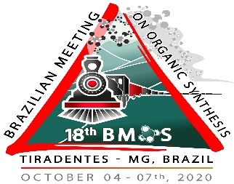

Title to submission (Font: Arial, 14)

Author A^{1*} and Author B² (Font: Arial, 10)
1) Department of Chemistry, Federal University of Minas Gerais, UFMG, 31270-901 (Font: Arial, 9)
2) Department of Chemistry, Federal University of Viçosa, UFV (Font: Arial, 9)
*e-mail: authorA@gmail.com (Font: Arial, 9)

Keywords: Catalysis, stereoselective synthesis, C-H activation. (Font: Arial, 9)
ABSTRACT
Enter a text with a maximum of 150 words (Font: Arial, 10).
If you judge necessary you can include scheme, graphic, table or figure.
ACKNOWLEDGEMENTS
Enter here foundings and/or supports for work (Font: Arial, 10).
REFERENCES
Use ACS rules for references (Font: Arial, 8).

Remember: your submission must fit within 1 page!

